**Introduction**

The topic of the project is "Game Management System”. We are using Oracle 10g to manage data, prevent security breaches, and provide seamless access to applications. This project is designed to keep a record of a Game Company, their games, developer of that company, their employees, manager who manage employees, server information on which games are played, and many more things. The game management system is developed by the company owners to manage different activities in the company. It saves time in carrying out daily activities and the automation of different processes brings efficiency to the system. It is a part of the corporate industry. The main purpose is to make our project easy and simple so that it can be implemented at any level and can be productive and useful for any game development company.

**Scenario**

In a Game Company Management System there will be a company which develops and releases games. Company has its name, unique license number, total employee, total number of games, address. City and country can be derived from address. The information of the game will be game name, game id, total sell, price size, release date. Release date consists of beta release date and global release date. Game id makes the game distinguished from other games. Under the company there will be many employees. Employee name, employee id, phone, salary, date of birth, age will be stored in the system. An employee can be uniquely identified by employee id. Company appoints manager to manage employee. Managers have unique manager id, manager name, email, salary, date of birth, age. Company hires developers for developing games. Developers have names, unique id, skill, email, salary, address. Game companies have their own server for storing and playing their game. Server id, server name, speed, capacity should be identifiers for server. Server id is different for each of the servers. Company has a marketing team. The marketing team offered offer. The marketing team has marketing team id, name, medium, license, rating, total ember. Marketing team is uniquely identified by their id. Unique offer id, offer name, discount, duration will be the offers for a client. A client can purchase game and his/her name, Cid, email, address, purchase date are also stored in the client. A Client can be uniquely identified by Cid.

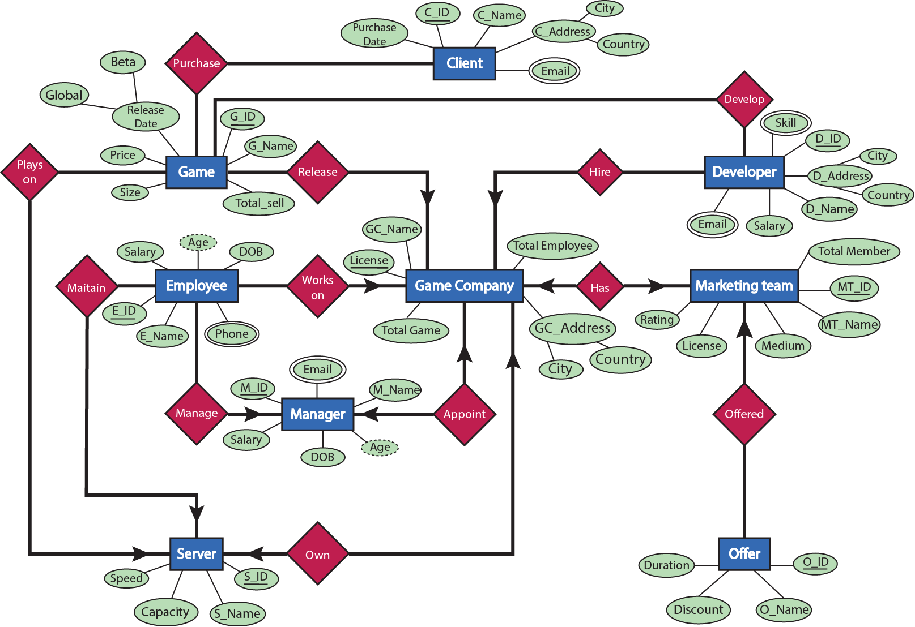 **ER Diagram**

**NORMALIZATION**

1.Game Company Release Game

UNF: G_ID, G_name, Size, Price, Total_sell, Beta, Global, GC_name, License, Total_Employee, Total_Game, city, country

1NF : 1st :G_ID, G_name, Size, Price, Total_sell, Beta, Global, GC_name, License, Total_Employee, Total_Game, city, country **(No Multi-value found)**

2NF : 1st : G_ID, G_name, Size, Price, Total_sell, Beta, Global, License (FK)

2nd: GC_name, License, Total_Employee, Total_Game, city, country

3NF: 1st: G_ID, G_name, Size, Price, Total_sell, Global, License (FK)

2nd: GC_name, License, Total_Employee, Total_Game, city

3rd: Global, Beta

4th: City, Country

2.Client Purchase Game

UNF : 1st: G_ID, G_name, Size, Price, Total_sell, Beta, Global, C_id, C_name, Purchase_Date, city, country, Email

1NF : 1st: G_ID, G_name, Size, Price, Total_sell, Beta, Global, C_id, C_name, Purchase_Date, city, country, Email **(Email is multivalued)**

2NF : 1st: G_ID, G_name, Size, Price, Total_sell, Beta, Global

2nd: C_id, C_name, Purchase_Date, city, country, Email

3rd: C_id (FK), G_id

3NF: 1st: G_ID, G_name, Size, Price, Total_sell, Global

2nd: C_id, C_name, Purchase_Date, City, Email

3rd: Global, Beta

4th: C_id (FK), G_id

5th: City, country

3.Game Plays_on Server

UNF: 1st: G_ID, G_name, Size, Price, Total_sell, Beta, Global, S_id, Speed, Capacity, S_name

1NF: 1st: G_ID, G_name, Size, Price, Total_sell, Beta, Global, S_id, Speed, Capacity, S_name **(No Multivalue)**

2NF : 1st: G_ID, G_name, Size, Price, Total_sell, Beta, Global, S_id

2nd: S_id, Speed, Capacity, S_name

3rd: G_id, S_id (FK)

3NF : 1st: G_ID, G_name, Size, Price, Total_sell, Global

2nd: S_id, Speed, Capacity, S_name

3rd: Global, Beta

4th: G_id, S_id (FK)

4.Developer Develop Game

UNF : 1st: G_ID, G_name, Size, Price, Total_sell, Beta, Global, D_id, city, country, D_name, Salary, Email, Skill

1NF : 1st: G_ID, G_name, Size, Price, Total_sell, Beta, Global, D_id, city, country, D_name, Salary, Email, Skill **(Skill & Email are Multivalued)**

2NF : 1st: G_ID, G_name, Size, Price, Total_sell, Beta, Global

2nd: D_id, D_name, Salary, Email, Skill_id

3rd: Skill_id, Skill

4th: G_id, D_id (FK)

3NF: 1st: G_ID, G_name, Size, Price, Total_sell, Global

2nd: D_id, city, D_name, Salary, Email, Skill_id

3rd: Skill_id, Skill

4th: G_id, D_id (FK)

5th: Global, Beta

6th: City, country

5.Game Company has Marketing Team

UNF: GC_name, License, Total_Employee, Total_Game, city, country, MT_id, MT_name, Medium, Licence, Rating

1NF : 1st: GC_name, License, Total_Employee, Total_Game, city, country, MT_id, MT_name, Medium, Licence, Rating **(No Multivalue)**

2NF: 1st: GC_name, License, Total_Employee, Total_Game, city, country, MT_id (FK)

2nd: MT_id, MT_name, Medium, Licence, Rating

3NF: 1st: GC_name, License, Total_Employee, Total_Game, city, MT_id (FK)

2nd: MT_id, MT_name, Medium, Licence, Rating

3rd: City, country

6.Marketing Team offered Offer.

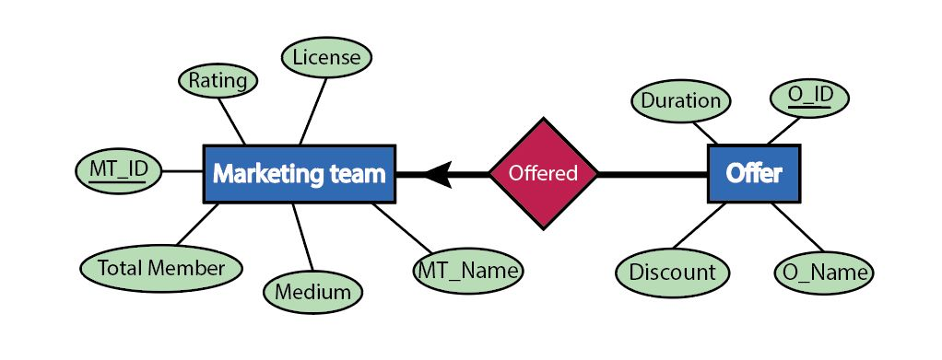

UNF: 1st: MT_id, MT_name, Medium, Licence, Rating, O_id, Duration, Discount, O_name

1NF: 1st: MT_id, MT_name, Medium, Licence, Rating, O_id, Duration, Discount, O_name **(No Multivalue)**

2NF: 1st: MT_id, MT_name, Medium, Licence, Rating

2nd: O_id, Duration, Discount, O_name, MT_id (FK)

3NF: 1st: MT_id, MT_name, Medium, Licence, Rating

2nd: O_id, Duration, Discount, O_name, MT_id (FK)

7.Game Company Hire Developer

UNF: 1st: GC_name, License, Total_Employee, Total_Game, city, country, D_id, D_name, Salary, Email, Skill

1NF: 1st: GC_name, License, Total_Employee, Total_Game, city, country, D_id, D_name, Salary, Email, Skill **(Skill & Email are Multivalued)**

2NF: 1st: GC_name, License, Total_Employee, Total_Game, city, country

2nd: D_id, D_name, Salary_id, Email, Skill, License (FK)

3NF: 1st: GC_name, License, Total_Employee, Total_Game, city

2nd: D_id, city, country, D_name, Salary_id, Email, Skill, License (FK)

3rd: City, Country

8.Employee Works on Game Company

UNF: 1st: GC_name, License, Total_Employee, Total_Game, city, country, E_id, E_name, Salary, Age, DOB, Phone

1NF: 1st: GC_name, License, Total_Employee, Total_Game, city, country, E_id, E_name, Salary, Age, DOB, Phone (**Phone is multivalued)**

2NF: 1st: GC_name, License, Total_Employee, Total_Game, city, country

2nd: E_id, E_name, Salary, Age, DOB, Phone, License (FK)

3NF: 1st: GC_name, License, Total_Employee, Total_Game, city

2nd: E_id, E_name, Salary, Age, DOB, Phone, city, License (FK)

3rd: City, Country

9.Game Company Appoint Manager

UNF : 1st: GC_name, License, Total_Employee, Total_Game, city, country, M_ID, M_name, Age, DOB, Salary, Phone **(Email is Multivalued)**

1NF: 1st: GC_name, License, Total_Employee, Total_Game, M_ID, M_name, Age, DOB, Salary, Email, City, Country

2NF: 1st: GC_name, License, Total_Employee, Total_Game, City, country

2nd: M_ID, M_name, Age, DOB, Salary, Email, License (FK)

3NF: 1st: GC_name, License, Total_Employee, Total_Game, city

2nd: M_ID, M_name, Age, DOB, Salary, Email, License (FK)

3rd: City, Country

10.Game Company Owns Server

UNF: 1st: GC_name, License, Total_Employee, Total_Game, city, country, S_id, Speed, Capacity, S_name

1NF: 1st: GC_name, License, Total_Employee, Total_Game, city, country, S_id, Speed, Capacity, S_name  **(No Multivalue)**

2NF: 1st: GC_name, License, Total_Employee, Total_Game, city, country

2nd: S_id, Speed, Capacity, S_name, License (FK)

3NF: 1st: GC_name, License, Total_Employee, Total_Game, city

2nd: S_id, Speed, Capacity, S_name, License (FK)

3rd: City, Country

11.Employee Maintain Server

UNF: 1st: E_id, E_name, Salary, Age, DOB, Phone, S_id, Speed, Capacity, S_name

1NF: 1st: E_id, E_name, Salary, Age, DOB, Phone, S_id, Speed, Capacity, S_name **(Phone Multivalued)**

2NF: 1st: E_id, E_name, Salary, Age, DOB, Phone, S_id (FK)

2nd: S_id, Speed, Capacity, S_name

3NF: 1st: E_id, E_name, Salary, Age, DOB, Phone, S_id (FK)

2nd: S_id, Speed, Capacity, S_name

12.Manager manage Employee

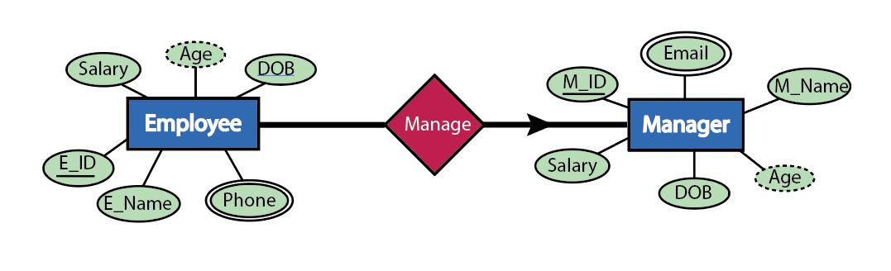

UNF: 1st: M_ID, M_name, Age, DOB, Salary, Phone, E_id, E_name, Salary, Age, DOB, Phone

1NF: 1st: M_ID, M_name, Age, DOB, Salary, Email, E_id, E_name, Salary, Age, DOB, Phone **(Phone & Email Multivalued)**

2NF: 1st: M_ID, M_name, Age, DOB, Salary, Email

2nd: E_id, E_name, Salary, Age, DOB, Phone, M_id(FK)

3NF: 1st: M_ID, M_name, Age, DOB, Salary, Email

2nd: E_id, E_name, Salary, Age, DOB, Phone, M_id(FK)

**FINALIZATION**

**Final Table**

1st: G_ID, G_name, Size, Price, Total_sell, Global, License (FK)

2nd: GC_name, License, Total_Employee, Total_Game, City

3rd: Global, Beta

4th: City, Country

5th: C_id, C_name, Purchase_Date, City, Email

6th: C_id (FK), G_id

7th: G_id, S_id (FK)

8th: Skill_id, Skill

9th: G_id, D_id (FK)

10th : GC_name, License, Total_Employee, Total_Game, city, MT_id (FK)

11th: MT_id, MT_name, Medium, Licence, Rating

12th: O_id, Duration, Discount, O_name, MT_id (FK)

13th: D_id, D_name, Salary, Email, Skill_id, License (FK)

14th: E_id, E_name, Salary, Age, DOB, Phone, City, License (FK)

15th: M_ID, M_name, Age, DOB, Salary, Email, License (FK)

16st: S_id, Speed, Capacity, S_name, License (FK)

17nd: E_id, E_name, Salary, Age, DOB, Phone, S_id (FK)

18th : E_id, E_name, Salary, Age, DOB, Phone, M_id(FK)

**TABLE CREATION**

1.CREATE TABLE GAME (G_ID NUMERIC NOT NULL, G_NAME VARCHAR2 (50), G_SIZE VARCHAR2 (20), PRICE NUMERIC, TOTAL_SELL NUMERIC NOT NULL, GLOBAL_RELEASE DATE, LICENSE NUMERIC NOT NULL, CONSTRAINT GAME_PK PRIMARY KEY (G_ID),CONSTRAINT GAME_FK FOREIGN KEY (LICENSE) REFERENCES GAME_COMPANY(LICENSE));

2. CREATE TABLE GAME_COMPANY (GC_NAME VARCHAR2 (50), LICENSE NUMERIC NOT NULL, TOTAL_EMPLOYEE NUMERIC, TOTAL_GAME NUMERIC, CITY VARCHAR2 (50), CONSTRAINT GC_PK PRIMARY KEY (LICENSE));

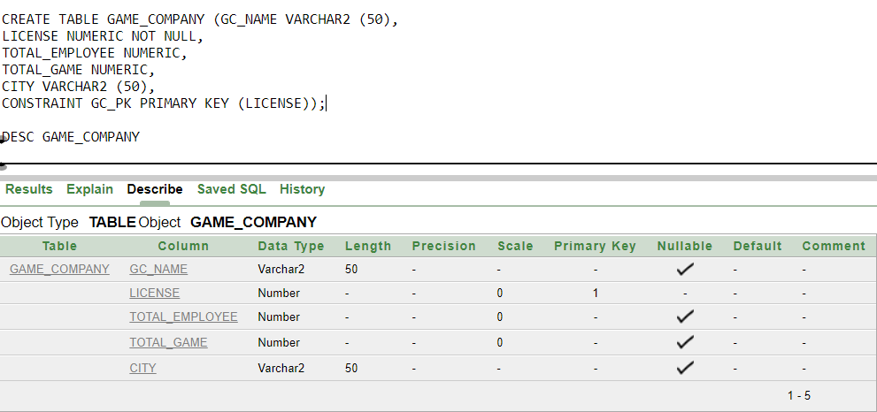

3. CREATE TABLE GAME_LAUNCH (GLOBAL DATE, BETA DATE, CONSTRAINT GL_PK PRIMARY KEY (GLOBAL));

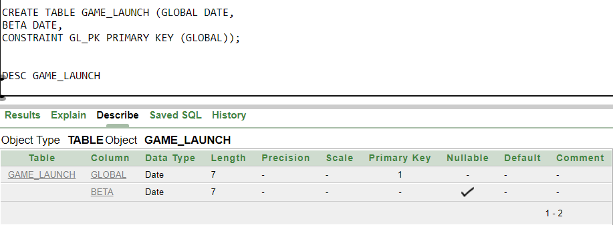

4. CREATE TABLE PLACE (CITY VARCHAR2(20), COUNTRY VARCHAR2 (20), CONSTRAINT PLACE_PK PRIMARY KEY (CITY));

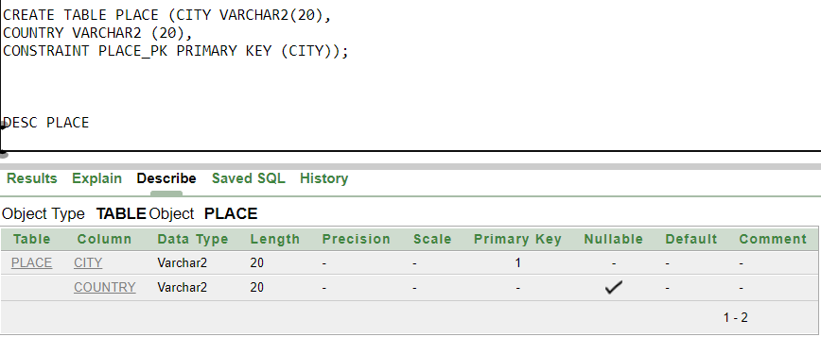

5. CREATE TABLE CLIENT (C_ID NUMERIC NOT NULL, C_NAME VARCHAR2(50), PURCHASE_DATE DATE, CITY VARCHAR2 (50), EMAIL_ID VARCHAR2 (50), CONSTRAINT CLIENT_PK PRIMARY KEY(C_ID));

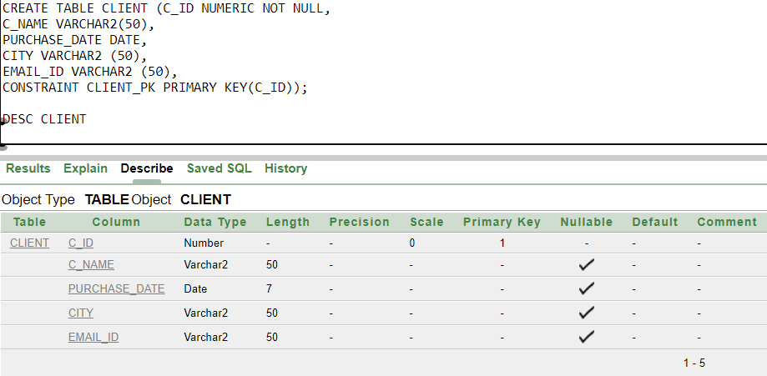

6.CREATE TABLE GAME_CLIENT (G_ID NUMERIC NOT NULL, C_ID NUMERIC NOT NULL, CONSTRAINT GAME_CLIENT_PK PRIMARY KEY (G_ID), CONSTRAINT GAME_CLIENT_FK FOREIGN KEY (C_ID) REFERENCES CLIENT (C_ID));

7.CREATE TABLE SERV_MANAGE (G_ID NUMERIC NOT NULL PRIMARY KEY, S_ID NUMERIC (10,10) NOT NULL, FOREIGN KEY (S_ID) REFERENCES SERVER(S_ID));

8.CREATE TABLE SKILL (SKILL_ID NUMERIC NOT NULL PRIMARY KEY, SKILL VARCHAR2(50));

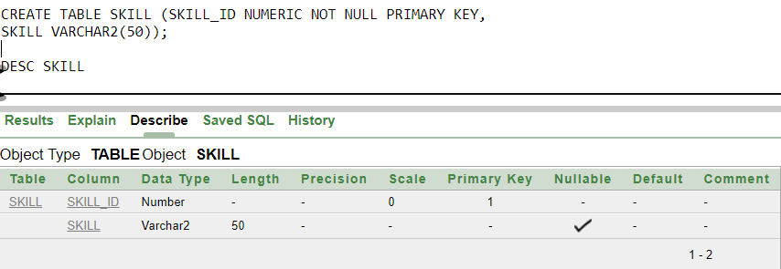

9.CREATE TABLE GAME_DEV (G_ID NUMERIC NOT NULL PRIMARY KEY, D_ID NUMERIC NOT NULL, CONSTRAINT D_ID_FK FOREIGN KEY (D_ID) REFERENCES DEVELOPER (D_ID));

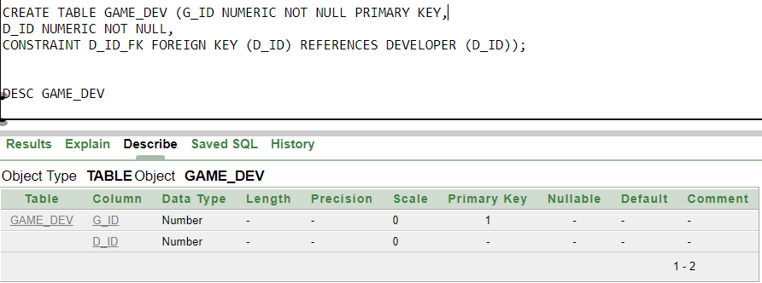

10. CREATE TABLE GAME_COMPANY_MT (GC_NAME VARCHAR2 (50), LICENSE NUMERIC NOT NULL PRIMARY KEY, TOTAL_EMPLOYEE NUMERIC, CITY VARCHAR2(50), MT_ID NUMERIC NOT NULL, CONSTRAINT MT_ID_FK FOREIGN KEY (MT_ID) REFERENCES MARKETING_TEAM (MT_ID));

11.CREATE TABLE MARKETING_TEAM (MT_ID NUMERIC NOT NULL PRIMARY KEY, MT_NAME VARCHAR2 (50), MEDIUM VARCHAR2 (50), LICENSE NUMERIC NOT NULL, RATING VARCHAR2 (50));

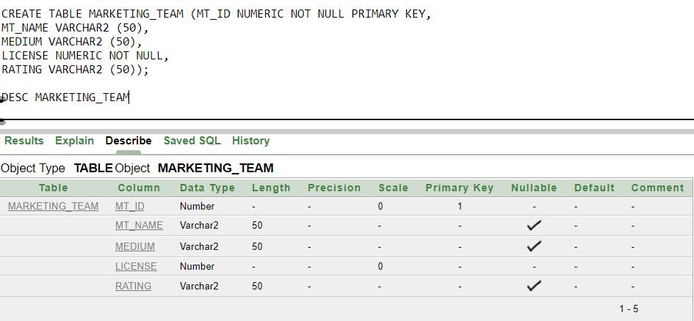

12. CREATE TABLE OFFER (O_ID NUMERIC NOT NULL PRIMARY KEY, DURATION VARCHAR2 (50), DISCOUNT VARCHAR2 (50), O_NAME VARCHAR (50), MT_ID NUMERIC NOT NULL, CONSTRAINT ORDER_FK FOREIGN KEY (MT_ID) REFERENCES MARKETING_TEAM (MT_ID));

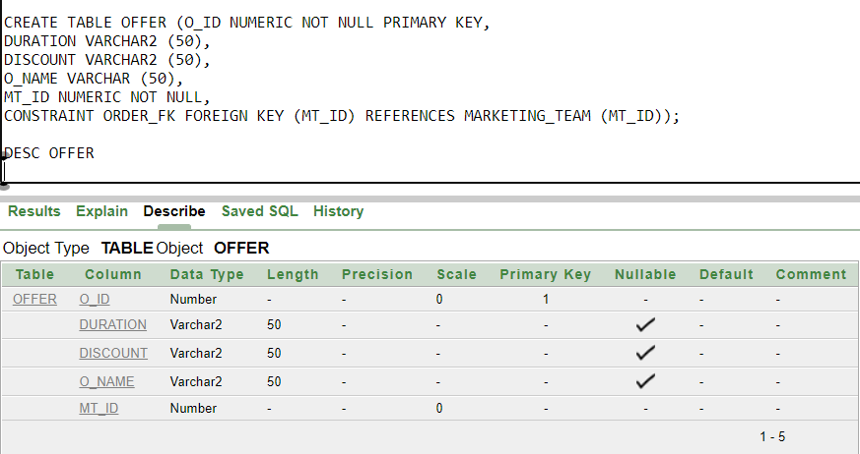

13. CREATE TABLE DEVELOPER (D_ID NUMERIC NOT NULL PRIMARY KEY, D_NAME VARCHAR2 (50), SALARY NUMERIC, SKILL_ID NUMERIC, LICENSE NUMERIC NOT NULL, CONSTRAINT DEVELOPER_FK FOREIGN KEY (LICENSE) REFERENCES GAME_COMPANY (LICENSE));

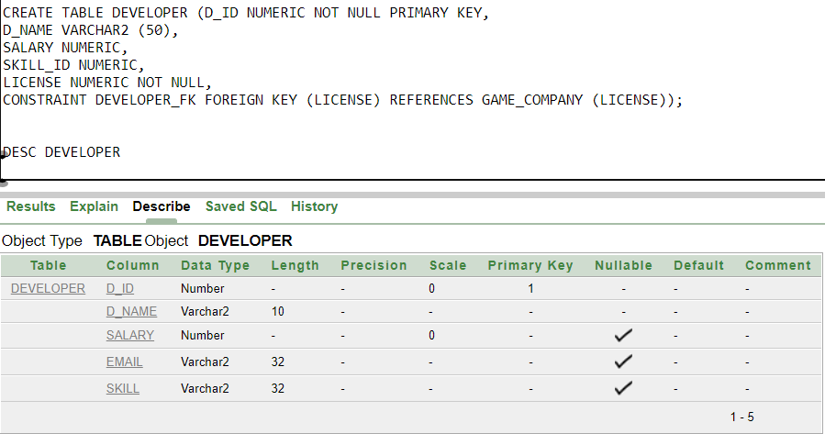

14. CREATE TABLE EMPLOYEE (E_ID NUMERIC NOT NULL PRIMARY KEY, E_NAME VARCHAR2 (50), SALARY NUMERIC, AGE NUMERIC, DOB DATE, PHONE VARCHAR2 (50), CITY VARCHAR2 (50), LICENSE NUMERIC NOT NULL, CONSTRAINT EMPLOYEE_FK FOREIGN KEY (LICENSE) REFERENCES GAME_COMPANY (LICENSE));

15. CREATE TABLE GAME_MANAGER (M_ID NUMERIC NOT NULL PRIMARY KEY ,M_NAME VARCHAR2(50), AGE NUMERIC, DOB DATE, SALARY NUMERIC, EMAIL VARCHAR2(50), LICENSE NUMERIC NOT NULL, CONSTRAINT GAME_MANAGER_FK FOREIGN KEY (LICENSE) REFERENCES GAME_COMPANY (LICENSE));

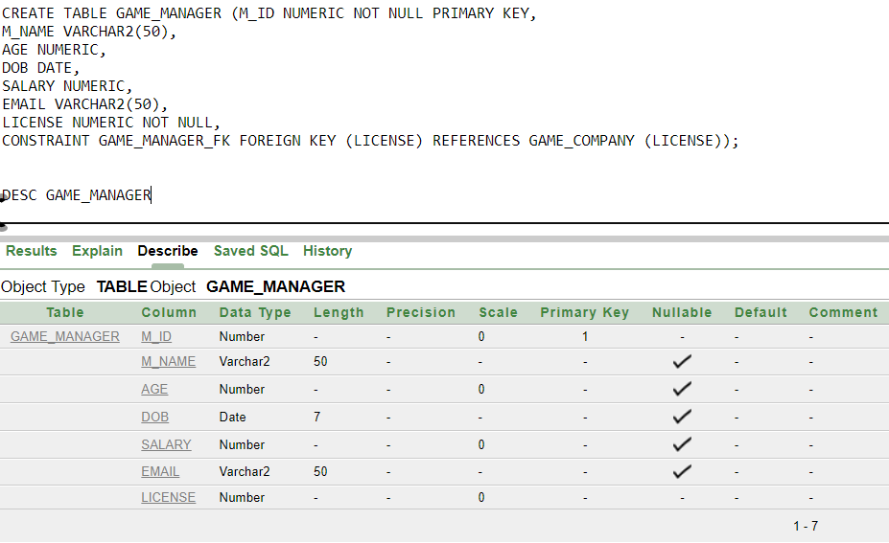

16. CREATE TABLE SERVER (S_ID NUMERIC NOT NULL PRIMARY KEY, SPEED VARCHAR2(50), CAPACITY VARCHAR2 (50), S_NAME VARCHAR2(50), LICENSE NUMERIC NOT NULL, CONSTRAINT GAME_SERVER_FK FOREIGN KEY (LICENSE) REFERENCES GAME_COMPANY (LICENSE));

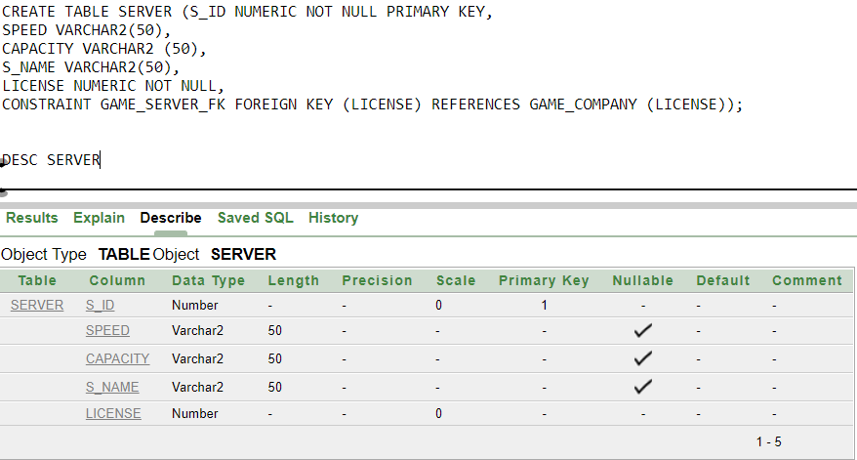

17. CREATE TABLE SERVER_EMPLOYEE (E_ID NUMERIC NOT NULL PRIMARY KEY, E_NAME VARCHAR2 (50), SALARY NUMERIC, AGE NUMERIC, DOB DATE, PHONE VARCHAR2 (50), S_ID NUMERIC NOT NULL, CONSTRAINT SERVER_EMPLOYEE_FK FOREIGN KEY (S_ID) REFERENCES SERVER (S_ID));

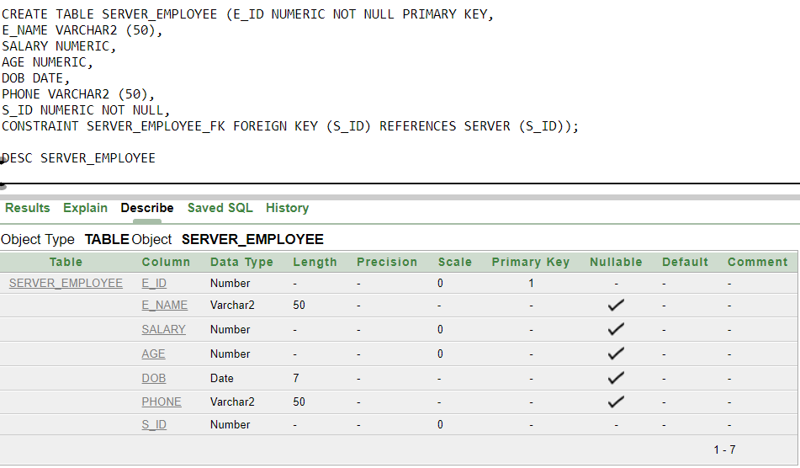

18. CREATE TABLE EMPLOYEE_MANAGER (E_ID NUMERIC NOT NULL PRIMARY KEY, E_NAME VARCHAR2 (50), SALARY NUMERIC, AGE NUMERIC, PHONE VARCHAR2 (50), M_ID NUMERIC NOT NULL, CONSTRAINT EMPLOYEE_MANAGER_FK FOREIGN KEY (M_ID) REFERENCES GAME_MANAGER (M_ID));

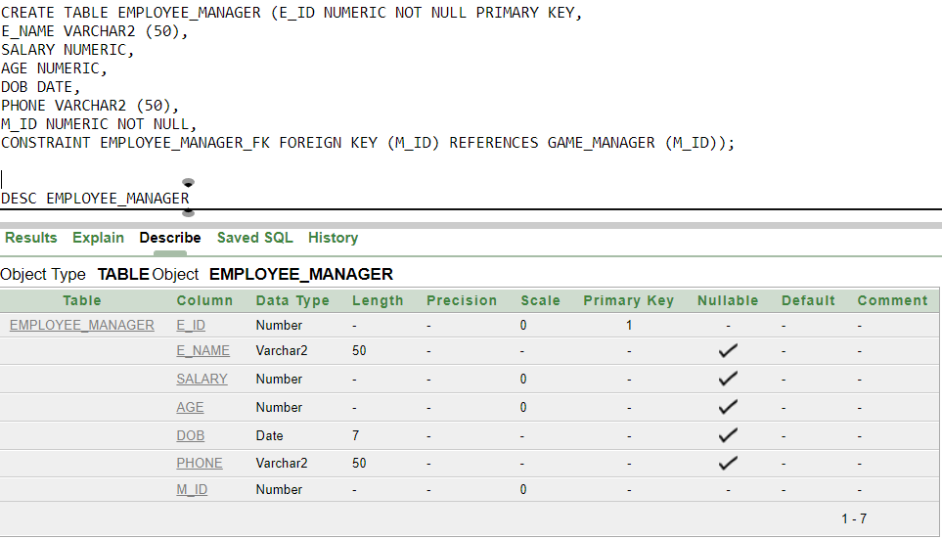

**Value Insertion**

1. GAME

INSERT INTO GAME VALUES (223,'PUBG','2.6 GB',21,1000000,'23-March-2017',002349);

INSERT INTO GAME VALUES (270,'COD','3.5 GB',29,1000000,'29-October-2003',778000);

INSERT INTO GAME VALUES (12,'VALORANT','130 GB',41,10000000,'2-June-2020',100800);

INSERT INTO GAME VALUES (010,'Mobile Legends','320 GB',12,90000000,'9-November-2016',990900);

INSERT INTO GAME VALUES (025,'DOTA 2','36 GB',45,124500000,'8-January-2014',320720);

SELECT * FROM GAME

1. GAME_COMPANY

INSERT INTO GAME_COMPANY VALUES('KRAFTON',002349,10000,12,'Bercelona')

INSERT INTO GAME_COMPANY VALUES ('ACTIVISION',778000,70560,18,'Santa Monica') ;

INSERT INTO GAME_COMPANY VALUES ('Riot Games',100800,80000,21,' Los Angeles') ;

INSERT INTO GAME_COMPANY VALUES ('MOBA',990900,1000250,209,' Shanghai') ;

INSERT INTO GAME_COMPANY VALUES ('Ubisoft',320720,1046751,4533,' Auckland') ;

SELECT * FROM GAME_COMPANY

1. GAME_LAUNCH

INSERT INTO GAME_LAUNCH VALUES('23-March-2017','3-January-2017');

INSERT INTO GAME_LAUNCH VALUES('29-October-2003','29-October-2003');

INSERT INTO GAME_LAUNCH VALUES('2-June-2020','21-December-2019');

INSERT INTO GAME_LAUNCH VALUES('9-November-2016','14-February-2016');

INSERT INTO GAME_LAUNCH VALUES('16-October-2016','03-February-2013');

SELECT * FROM GAME_LAUNCH

1. CLIENT

INSERT INTO CLIENT VALUES (2199,'SAYEM','21-January-2021','DHAKA’, ‘sayem@gmail.com');

INSERT INTO CLIENT VALUES (1908,'RASSEL','12-January-2020','KHULNA’, ‘rassel21@gmail.com');

INSERT INTO CLIENT VALUES (1955,'TAMIM','01-DECEMBER-2019','DHAKA’, ‘tamimahmed@gmail.com');

INSERT INTO CLIENT VALUES (1795,'SEUM','01-DECEMBER-2022','DHAKA’, ‘seum23@gmail.com');

INSERT INTO CLIENT VALUES (3521,'KABIR','07-NOVEMBER-2019','DINAJPUR’, ‘kabir013@gmail.com');

SELECT * FROM CLIENT

1. GAME_CLIENT

INSERT INTO GAME_CLIENT VALUES (12,2199);

INSERT INTO GAME_CLIENT VALUES (010,1908);

INSERT INTO GAME_CLIENT VALUES (270,1955);

INSERT INTO GAME_CLIENT VALUES (223,1795);

INSERT INTO GAME_CLIENT VALUES (223,1795);

SELECT * FROM GAME_CLIENT

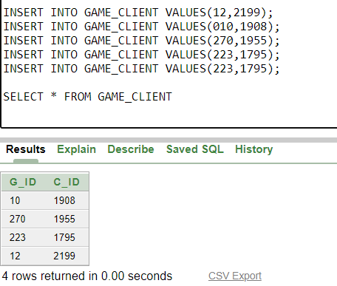

1. SERV_MANAGE

INSERT INTO SERV_MANAGE VALUES (12,12099);

INSERT INTO SERV_MANAGE VALUES (010,21203);

INSERT INTO SERV_MANAGE VALUES (270,99601);

INSERT INTO SERV_MANAGE VALUES (223,70981);

INSERT INTO SERV_MANAGE VALUES (525,58932);

SELECT * FROM SERV_MANAGE

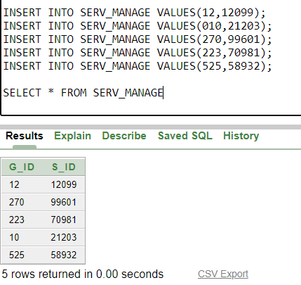

1. SERVER

INSERT INTO SERVER VALUES (12099,'2 GB/S',900000000,'ASIA',990900);

INSERT INTO SERVER VALUES (21203,'21 GB/S',600000000,'MIDDLE EAST',002349);

INSERT INTO SERVER VALUES (99601,'1 GB/S',20000000,'AFRICA',002349);

INSERT INTO SERVER VALUES (70981,'200 GB/S',600007500,'USA',100800);

INSERT INTO SERVER VALUES (58932,'200 GB/S',600007500,'USA',320720);

SELECT * FROM SERVER

1. SKILL

INSERT INTO SKILL VALUES (34506,'GRAPHIC');

INSERT INTO SKILL VALUES(45775,'ALGORITHM');

INSERT INTO SKILL VALUES (87952,'PROBLEM SOLVING');

INSERT INTO SKILL VALUES (98563,'GAME DESIGN');

INSERT INTO SKILL VALUES (32891,'AUDIO & VFX');

SELECT * FROM SKILL

1. DEVELOPER

INSERT INTO DEVELOPER VALUES (00034,'JONES',2100,34506,002349);

INSERT INTO DEVELOPER VALUES (00021,'DAVID',4200,45775,778000);

INSERT INTO DEVELOPER VALUES (00018,'JAMES',2220,87952,100800);

INSERT INTO DEVELOPER VALUES (00011,'STEPHEN',1890,98563,990900);

INSERT INTO DEVELOPER VALUES(00089,'WILL',1890,98563,320720);

SELECT * FROM DEVELOPER

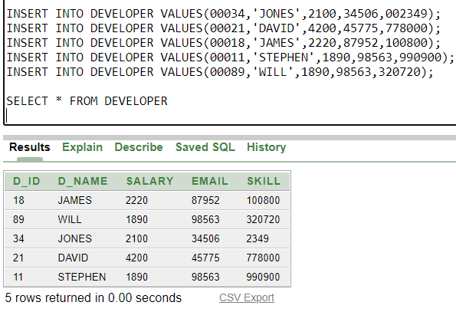

1. PLACE

INSERT INTO PLACE VALUES ('BERCELONA', 'SPAIN');

INSERT INTO PLACE VALUES ('SANTA MONICA', 'USA');

INSERT INTO PLACE VALUES ('LOS ANGELES', 'USA');

INSERT INTO PLACE VALUES ('SHANGHAI', 'CHINA');

INSERT INTO PLACE VALUES ('AUCKLAND', 'NEWZEALAND');

INSERT INTO PLACE VALUES ('DHAKA', 'BANGLADESH');

INSERT INTO PLACE VALUES ('KHULNA', 'BANGLADESH');

INSERT INTO PLACE VALUES ('KUSHTIA', 'BANGLADESH');

INSERT INTO PLACE VALUES ('COMILLA', 'BANGLADESH');

INSERT INTO PLACE VALUES ('DINAJPUR', 'BANGLADESH');

SELECT * FROM PLACE

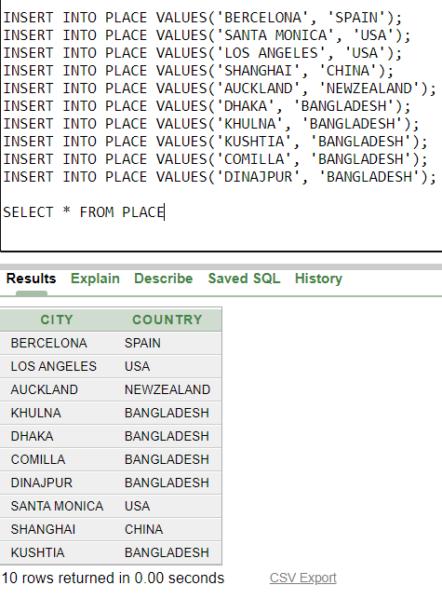

1. GAME_DEV

INSERT INTO GAME_DEV VALUES(223,00034);

INSERT INTO GAME_DEV VALUES (270,00021);

INSERT INTO GAME_DEV VALUES (12,00018);

INSERT INTO GAME_DEV VALUES (010,00011);

INSERT INTO GAME_DEV VALUES (525,00089);

SELECT * FROM GAME_DEV

1. GAME_COMPANY_MT

INSERT INTO GAME_COMPANY_MT VALUES('KRAFTON',002349,1700,'BERCELONA',0501);

INSERT INTO GAME_COMPANY_MT VALUES ('ACTIVISION',7780000,2100,'SANTA MONICA',0502);

INSERT INTO GAME_COMPANY_MT VALUES ('RIOT',100800,1250,'LOS ANGELES',0503);

INSERT INTO GAME_COMPANY_MT VALUES('MOBA',990900,1400,'SHANGHAI',0504);

INSERT INTO GAME_COMPANY_MT VALUES('UBISOFT',320720,1100,'AUCKLAND',0505);

SELECT * FROM GAME_COMPANY_MT

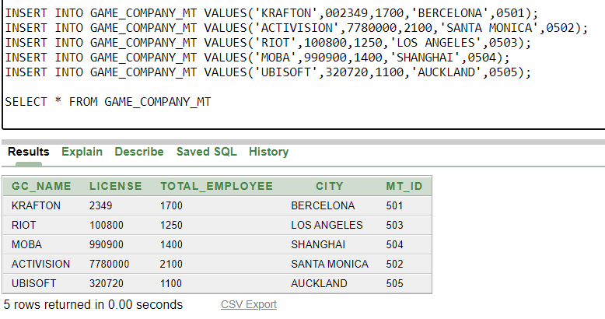

1. MARKETING_TEAM

INSERT INTO MARKETING_TEAM VALUES (0501,'RIDERS','FACEBOOK',1111,8.5);

INSERT INTO MARKETING_TEAM VALUES (0502,'KONG','YOUTUBE',2222,9.5);

INSERT INTO MARKETING_TEAM VALUES (0503,'FLUID','LINKED_IN',3333,7.0);

INSERT INTO MARKETING_TEAM VALUES (0504,'KNIGHT','TWITTER',4444,5.3);

INSERT INTO MARKETING_TEAM VALUES (0505,'PRINCE','INSTAGRAM',5555,6.5);

SELECT * FROM MARKETING_TEAM

1. OFFER

INSERT INTO OFFER VALUES (15,'7 DAYS','15%','CHEAP BUY',0501);

INSERT INTO OFFER VALUES (25,'5 DAYS','25%','EXCLUSIVE SALE',0502);

INSERT INTO OFFER VALUES (35,'15 DAYS','35%','SAVE YOUR PENNY',0503);

INSERT INTO OFFER VALUES (45,'5 DAYS','45%','BIG OFFER',0504);

INSERT INTO OFFER VALUES (55,'3 DAYS','55%','WINTER SALE',0505);

SELECT * FROM OFFER

1. EMPLOYEE

INSERT INTO EMPLOYEE VALUES (0011,'LORD',12000,28,'28-JAN-89',052211883,002349);

INSERT INTO EMPLOYEE VALUES (0022,'SMITH',15000,23,'14-MAR-03',052142546,320720);

INSERT INTO EMPLOYEE VALUES (0033,'BLAKE',9000,43,'31-DEC-76',052324643,100800);

INSERT INTO EMPLOYEE VALUES (0044,'WILLIUM',6700,25,'25-MAY-99',052231364,990900);

SELECT * FROM EMPLOYEE

1. GAME_MANAGER

INSERT INTO GAME_MANAGER VALUES (101,'BLAKE',40,'21-MAR-97',102000,'BLAKE@GMAIL.COM',002349);

INSERT INTO GAME_MANAGER VALUES (102,'SMITH',43,'23-APR-89',75000,'SMITH@GMAIL.COM',002349);

INSERT INTO GAME_MANAGER VALUES (103,'RICHARD',46,'12-JUN-95',81000,'RICHARD@GMAIL.COM',002349);

INSERT INTO GAME_MANAGER VALUES (104,'KANE',41,'27-DEC-92',99000, ‘KANE@GMAIL.COM',002349);

INSERT INTO GAME_MANAGER VALUES (105,'SHAWN',37,'16-MAY-99',100000,'SHAWN@GMAIL.COM',002349);

SELECT * FROM GAME_MANAGER

1. SERVER_EMPLOYEE

INSERT INTO SERVER_EMPLOYEE VALUES(0011,'RAFU',25000,35,'21-MAR-99',0171111111,12099);

INSERT INTO SERVER_EMPLOYEE VALUES(0022,'PIKO',75000,54,'23-JUL-88',0172222222,21203);

INSERT INTO SERVER_EMPLOYEE VALUES(0033,'SAFEEN',150000,39,'21-MAR-96',017333333,99601);

INSERT INTO SERVER_EMPLOYEE VALUES(0044,'RAILY',54000,48,'15-APR-97',0174444444,70981);

INSERT INTO SERVER_EMPLOYEE VALUES(0055,'GOMEZ',88000,61,'22-FEB-81',01755555555,58932);

SELECT * FROM SERVER_EMPLOYEE

1. SERVER_EMPLOYEE

INSERT INTO EMPLOYEE_MANAGER VALUES(0011,'KAFU',66000,52,'17-DEC-89',0800110022,101);

INSERT INTO EMPLOYEE_MANAGER VALUES(0022,'SAFI',35000,35,'13-NOV-03',0800330055,102);

INSERT INTO EMPLOYEE_MANAGER VALUES(0033,'SAYEF',61000,45,'31-MAY-95',0800660077,103);

INSERT INTO EMPLOYEE_MANAGER VALUES(0044,'NOMAN',57000,33,'29-JUN-97',0800880099,104);

INSERT INTO EMPLOYEE_MANAGER VALUES(0055,'LAFIZ',72000,53,'21-AUG-99',0800210012,105);

SELECT * FROM EMPLOYEE_MANAGER

**QUERY**

1. **SINGLE ROW SUBQUERY**

**QUESTION: Write a query to display e_id, e_name, phone from EMPLOYEE whose e_id is 33.**

SELECT E_ID, E_NAME, SALARY FROM EMPLOYEE WHERE E_NAME = (SELECT E_NAME FROM EMPLOYEE

WHERE E_ID = 33);

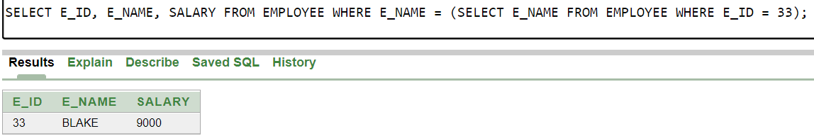

1. **AGGREGATE FUNCTON**

**QUESTION: Write a query to display how many rows are there in game company table?**

SELECT COUNT(GC_NAME) FROM GAME_COMPANY;

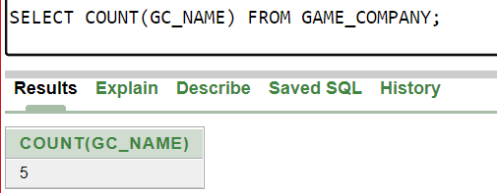

1. **MULTIPLE ROW SUBQUERY**

**QUESTION: Write a query to display e_id, e_name, phone from EMPLOYEE whose salary is greater**

**than that of WILLIUM.**

SELECT E_ID, E_NAME, PHONE FROM EMPLOYEE WHERE SALARY > ANY (SELECT SALARY FROM

EMPLOYEE WHERE E_NAME = 'WILLIUM');

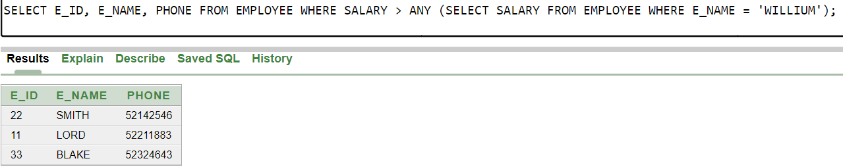

1. **EQUIJOIN FOR CLIENT & GAME_CLIENT TABLE**

**QUESTION: Create a join in CLIENT table and GAME_CLIENT table.**

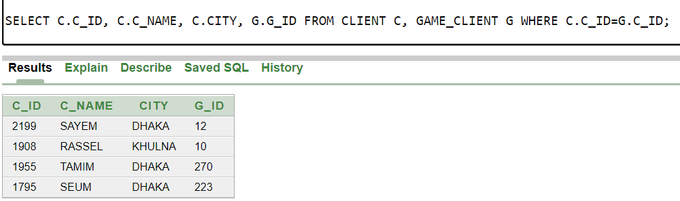SELECT C.C_ID, C.C_NAME, C.CITY, G.G_ID FROM CLIENT C, GAME_CLIENT G WHERE C.C_ID=G.C_ID;

1. **OUTERJOIN FOR GAME_COMPANY & EMPLOYEE**

**QUESTION:** **Write a query that will join the columns of GAME_COMPANY and EMPLOYEE. No rows of the stay table will be missed.**

SELECT E.E_NAME, E.SALARY, E.PHONE, G.GC_NAME, G.CITY FROM EMPLOYEE E, GAME_COMPANY G WHERE E.LICENSE(+)=G.LICENSE;

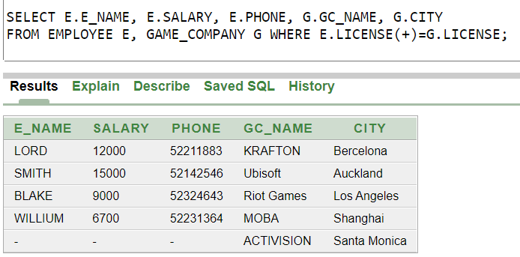

1. **CARTETIAN COMPLEXITY**

**QUESTION: Show Cartesian complexity between client & game client.**

SELECT C.C_ID, C.C_NAME, C.CITY, G.G_ID FROM CLIENT C, GAME_CLIENT G;

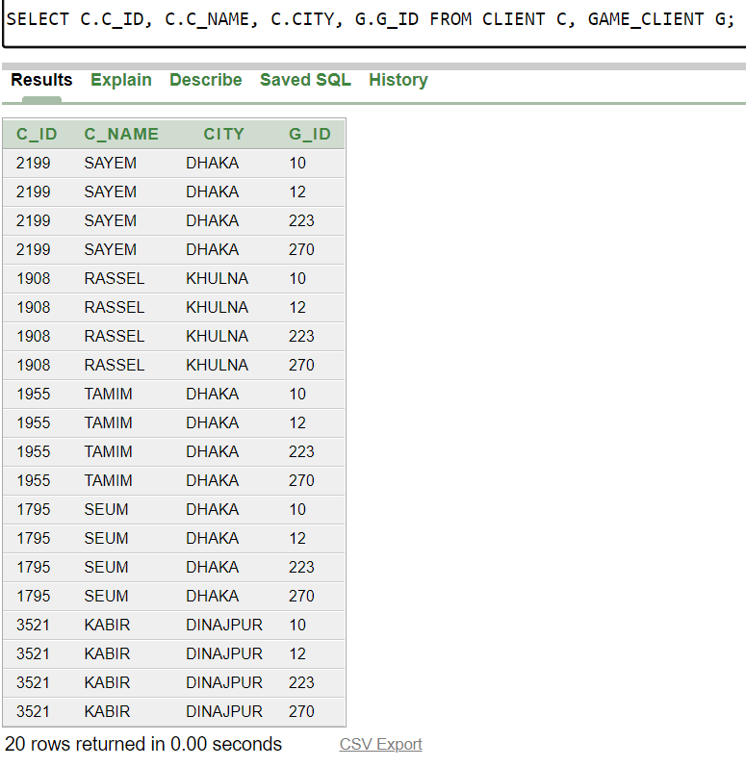

**VIEW**

**QUESTION: Create a view of table game company.**

CREATE VIEW GAME_COMPANY_PK AS SELECT GC_NAME, TOTAL_GAME, CITY FROM GAME_COMPANY;

SELECT * FROM GAME_COMPANY_PK;

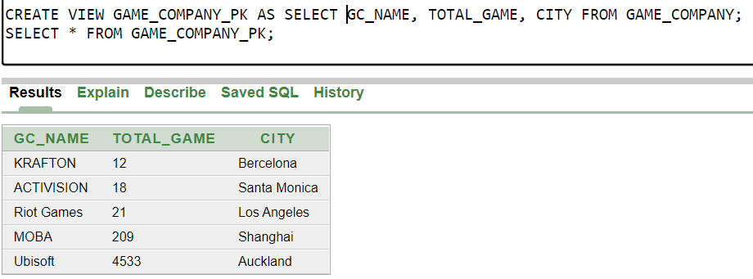

**SEQUENCE**

**QUESTION: Create and display a sequence start with 55, increase by 11.**

CREATE SEQUENCE EMPLOYEE_ID INCREMENT BY 11 START WITH 55 MAXVALUE 5555 NOCACHE

NOCYCLE;

SELECT SEQUENCE_NAME, MIN_VALUE, MAX_VALUE, INCREMENT_BY, LAST_NUMBER FROM

USER_SEQUENCES;

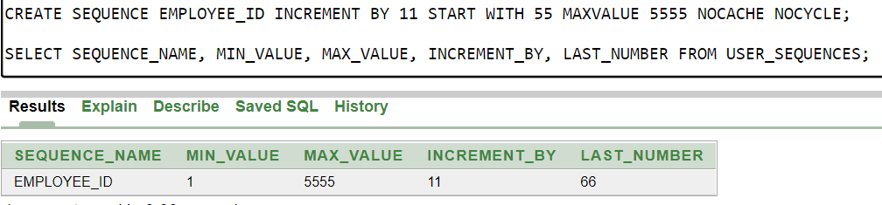

**Conclusion**

The term game company describes an establishment that develops and sells games. Employees of the company are managed by a manager. Marketing teams for the company make various offers to attract new clients and the company also owns a server to store their operational data in. To maintain all these games company-related work easily we have made this game company management system. This game company management system tries to cover all the aspects of running a company, but we can improve it for much more extensive models easily.

Entity: Game, Employee, Developers, Manager, Publisher, Server, Client, Offer, Game Company

Attributes

1. Game -> G_id (pk), Gname, Size, Copyright, Pric, Total_Sell, [Release Date]
2. Employee -> E_id(pk), Ename, Age, Date of Birth, Address (city, country), Phone, Salary, Skill
3. Developers -> D_id, Dname, Skill, Email, Salary (weak entity -> Yearly salary)
4. Manager -> M_id, Mname, Salary, {address, phone}
5. Marketing_Team ->MT_id, Rating, Medium, MTname, License, Total_Member
6. Server -> S_id, Capacity, Speed, Sname
7. Client -> C_id, Cname, Address, Purchase_History, Email
8. Game_Company -> GC_Name, License(PK), Address (City, Country), Total_Game, Total_Employee, Email
9. Offer -> Duration, O_Name, Discount, O_id

Relations

1. GC release Game
2. EMP works_on GC
3. GC hire DEvelopers
4. Dev develop games
5. Employee maintain Server
6. Client Purchase Games
7. GC owns Server
8. Manager Manage Emp
9. GC Appoints Manager
10. GC has Marketing_team
11. Marketing_team offered Offers